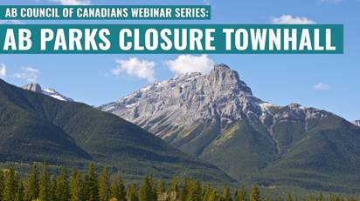

Event: Alberta Parks Closure Town Hall
Date: Wednesday June 17, 2020
Time: 7:00 PM
Registration: https://us02web.zoom.us/webinar/register/WN_jN_8NsukSkez6vam40_UEA
After registering, you will receive a confirmation email containing information about joining the webinar.

The Government of Alberta plans to remove 175 of Alberta’s provincial parks from the park system without public consultation or park-by-park justification.
The Edmonton, Red Deer, Calgary, and Medicine Hat Chapters of the Council of Canadians will hold an online Alberta-wide town hall meeting on June 17, 2020 to discuss this threat.
Expert speakers will explain the implications of the plan and suggest ways to respond. There will be an opportunity to submit written questions to the speakers.
Attend this event and join 100's of other conservation-minded individuals and organizations who care about our parks and are concerned about this plan.
Agenda:
Welcome: Richard Merry (Council of Canadians)
Council of Canadians overview/context: Peter Loney (Council of Canadians)
Speakers: Chris Smith & Steve Donelon (Canadian Parks and Wilderness Society - CPAWS)
Questions: Answered by speakers as feasible
Summary/taking action/Wrap-up: Richard Merry (Council of Canadians)

Guest Speakers
Christopher Smith - Parks Coordinator, Canadian Parks & Wilderness Society Northern Alberta
Chris has professional experience in industry, government and not-for-profits. He has worked on transboundary protected areas along the Canadian/USA and German/Czech Republic borders. His employment with CPAWS Northern Alberta since 2018 includes the ‘Love Your Headwaters’ campaign in Alberta’s Bighorn Country – an effort similar to his current focus on the UCP’s plan to de-list 175 Alberta parks.
Education
- BSc in Forestry, Environmental Studies Major; Masters in Environmental Management (University of New Brunswick).
- MSc in Forest Ecology and Management (Freiburg University, Germany)

Steve Donelon, Board Chair , CPAWS Northern Alberta
Steve was born in Alberta, growing up in Edmonton and near Bentley. His wilderness appreciation comes especially from camping, hiking and climbing along Alberta’s Eastern Slopes. With conservation at the core of his values, Steve began a career with Alberta Parks in 1981.
Experience
- 30 years parks work including Regional Director for Kananaskis Country.
- 2011-2015 - Alberta Parks Provincial Operations program
- 2015-2018, Assistant Deputy Minister, Alberta Parks Program
- Co-led “Pathway to Canada Target 1” for Canada’s role in the Convention on Bio-Diversity.
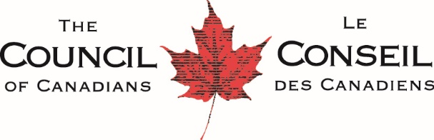
The Council of Canadians is a national social action organization that advocates for clean water, fair trade, green energy, public health care, and a vibrant democracy. We believe strongly in the protection of the commons, those ecological, social and cultural resources and heritages that are shared by all.
The Alberta chapters of the Council of Canadians believe that the parks are the heritage of all Albertans, providing recreation, conservation and other values. All of these values need recognition in any changes to their status.
The Alberta Parks Closure Town Hall is the first of a series of event this spring and summer to raise awareness of issues of importance to Albertans.

